Step 1 – Create Flow
Create a new flow in ServiceNow Flow Designer.
Flow Name:
Auto Ticket Classification
Purpose:
To automatically process and classify incident tickets based on predefined conditions.
Image:
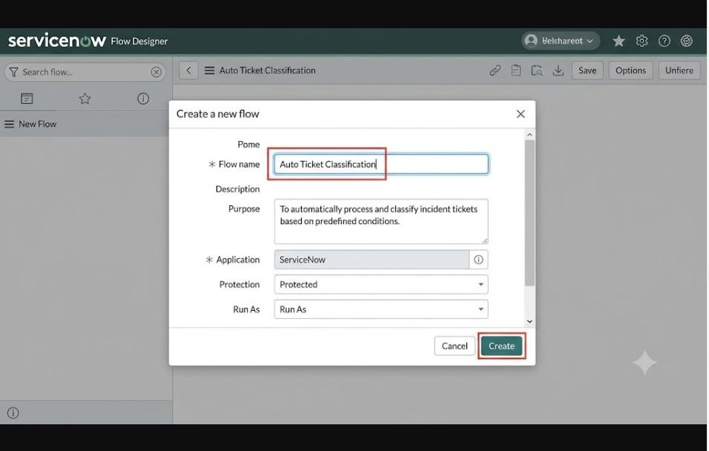
Caption:
Figure 1: Creating the Auto Ticket Classification Flow

Step 2 – Configure Trigger
Configure the trigger to start the flow when an incident/ticket is created or when the required ticket condition is met.
Image:
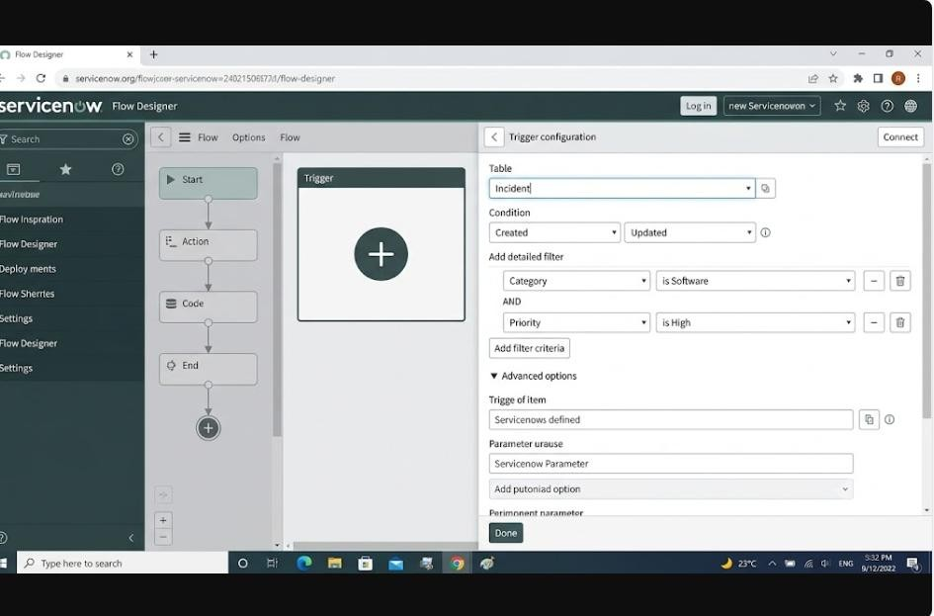
Caption:
Figure 2: Configuring the Flow Trigger

Step 3 – Configure Ticket Conditions
Add conditions to check the ticket information and determine how the ticket should be classified.
Image:

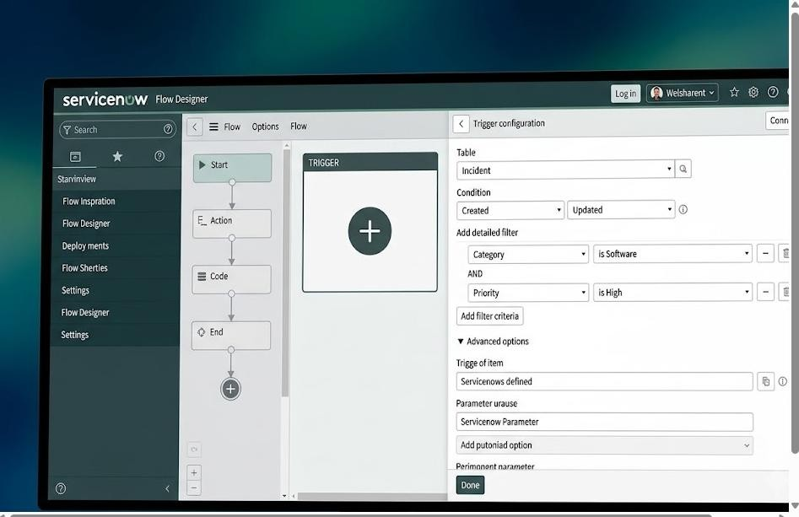
.
Caption:
Figure 3: Configuring Ticket Classification Conditions

Step 4 – Configure Assignment Group
Configure the action to assign the ticket to the appropriate assignment group based on the classification.
Image:
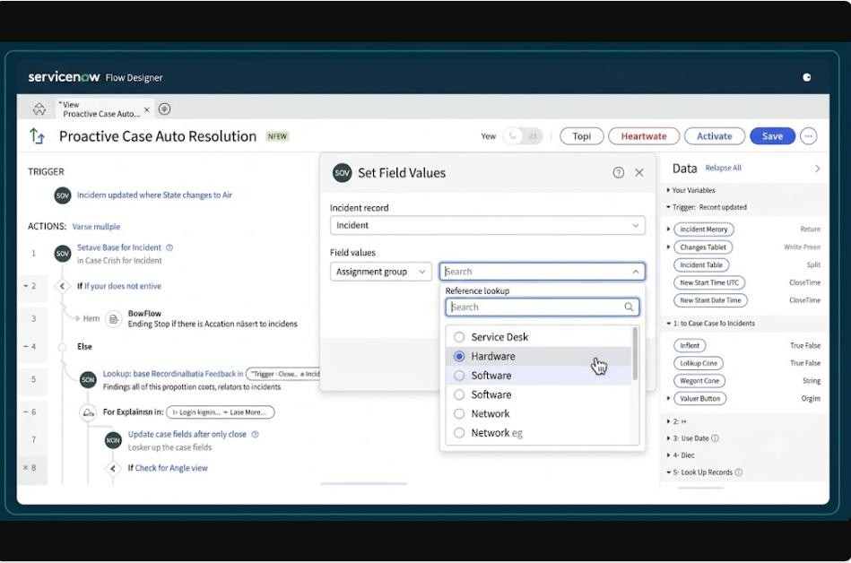
Caption:
Figure 4: Configuring the Assignment Group

Step 5 – Save and Activate the Flow
Save the flow and make sure the configured flow is ready for execution.
Image:
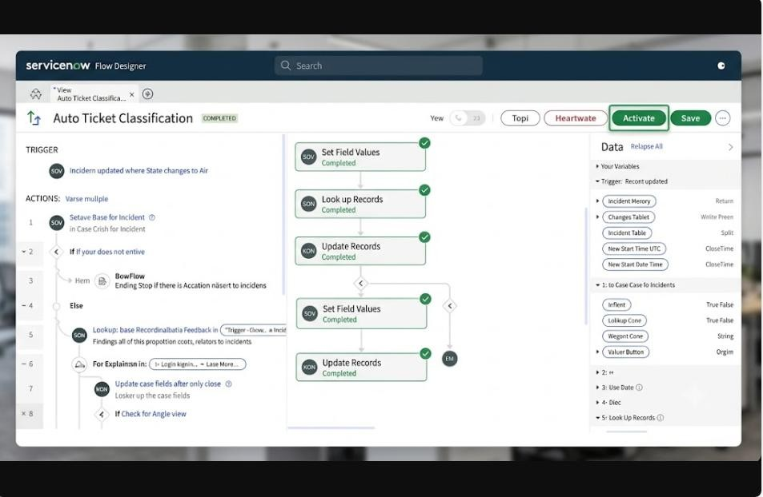
.Caption:
Figure 5: Completed Auto Ticket Classification Flow

